VISVESVARAYA TECHNOLOGICAL UNIVERSITY
“JnanaSangama”, Belgaum -590014, Karnataka.


LAB REPORT

On

ANALYSIS AND DESIGN OF ALGORITHMS (23CS4PCADA)

Submitted by

KIRTI SINGH (1BF24CS141)

in partial fulfillment for the award of the degree of
BACHELOR OF ENGINEERING
in
COMPUTER SCIENCE AND ENGINEERING



B.M.S. COLLEGE OF ENGINEERING
(Autonomous Institution under VTU)
BENGALURU-560019
February to June 2026
CERTIFICATE

B. M. S. College of Engineering,
Bull Temple Road, Bangalore 560019
(Affiliated To Visvesvaraya Technological University, Belgaum)
Department of Computer Science and Engineering



This is to certify that the Lab work entitled “ANALYSIS AND DESIGN OF ALGORITHMS” carried out by Kirti Singh(1BF24CS141) who is bonafide student of B. M. S. College of Engineering. It is in partial fulfillment for the award of Bachelor of Engineering in Computer Science and Engineering of the Visvesvaraya Technological University, Belgaum during the year 2025-26. The Lab report has been approved as it satisfies the academic requirements in respect of Analysis and Design of Algorithms Lab - (23CS4PCADA) work prescribed for the said degree.

Prof. Manjula S Dr. Kavitha Sooda
Assistant Professor Professor and Head
Department of CSE Department of CSE
BMSCE, Bengaluru BMSCE, Bengaluru

Index Sheet
Sl.  No. | Experiment Title | Page No.
1 | Write program to obtain the Topological ordering of vertices in a given digraph.
2 | Implement Johnson Trotter algorithm to generate permutations.
3 | Sort a given set of N integer elements using Merge Sort technique and compute its time taken. Run the program for different values of N and record the time taken to sort.
4 | Sort a given set of N integer elements using Quick Sort technique and compute its time taken.
5 | Sort a given set of N integer elements using Heap Sort technique and compute its time taken.
6 | Implement 0/1 Knapsack problem using dynamic programming. (5 Marks)
7 | Implement All Pair Shortest paths problem using Floyd’s algorithm.
8 | - Find Minimum Cost Spanning Tree of a given undirected graph using Prim’s algorithm.  - Find Minimum Cost Spanning Tree of a given undirected graph using Kruskal’s algorithm.
9 | Implement Fractional Knapsack using Greedy technique.
10 | From a given vertex in a weighted connected graph, find shortest paths to other vertices using Dijkstra’s algorithm.
11 | Implement “N-Queens Problem” using Backtracking.

Course outcomes:
CO1 | Analyze time complexity of algorithms using asymptotic notations.
CO2 | Apply various algorithm design techniques for the given problem.
CO3 | Evaluate the appropriate algorithm/design technique for solving a given problem.
CO4 | Conduct practical experiments by applying appropriate algorithm design technique to solve problems.

Lab program 1:
Write program to obtain the Topological ordering of vertices in a given digraph.
#include <stdio.h>
#define MAX 10
int main() {
int n, i, j;
int indegree[MAX] = {0};
int graph[MAX][MAX];
int order[MAX], count = 0;
printf("Enter number of vertices: ");
scanf("%d", &n);
printf("Enter adjacency matrix:\n");
for(i = 0; i < n; i++) {
for(j = 0; j < n; j++) {
scanf("%d", &graph[i][j]);
if(graph[i][j] == 1) {
indegree[j]++;
}
}
}
while(count < n) {
int found = 0;
for(i = 0; i < n; i++) {
if(indegree[i] == 0) {
order[count++] = i;
indegree[i] = -1;
for(j = 0; j < n; j++) {
if(graph[i][j] == 1) {
indegree[j]--;
}
}
found = 1;
}
}
if(!found) break;
}
if(count < n) {
printf("No Topological Sequence (cycle detected)\n");
} else {
printf("Topological Order: ");
for(i = 0; i < n; i++) {
printf("%d ", order[i]);
}
printf("\n");
}
return 0;
}

Screenshot of the output:
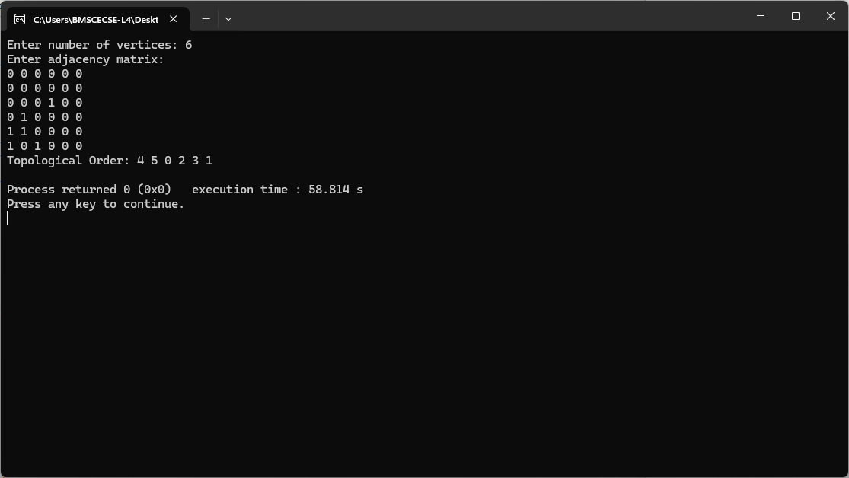

Lab program 2:
Implement Johnson Trotter algorithm to generate permutations.
#include <stdio.h>
#define LEFT 0
#define RIGHT 1
void print(int a[], int dir[], int n) {
for(int i = 0; i < n; i++) {
if(dir[a[i]] == LEFT)
printf("%d<- ", a[i]);
else
printf("%d-> ", a[i]);
}
printf("\n");
}

int getMobile(int a[], int dir[], int n) {
int mobile = 0;

for(int i = 0; i < n; i++) {

if(dir[a[i]] == LEFT && i > 0) {
if(a[i] > a[i-1] && a[i] > mobile)
mobile = a[i];
}

if(dir[a[i]] == RIGHT && i < n-1) {
if(a[i] > a[i+1] && a[i] > mobile)
mobile = a[i];
}
}
return mobile;
}

int findPos(int a[], int n, int mobile) {
for(int i = 0; i < n; i++) {
if(a[i] == mobile)
return i;
}
return -1;
}

void johnsonTrotter(int n) {
int a[n], dir[n+1];

for(int i = 0; i < n; i++) {
a[i] = i + 1;
dir[i+1] = LEFT;
}

print(a, dir, n);

while(1) {
int mobile = getMobile(a, dir, n);

if(mobile == 0)
break;

int pos = findPos(a, n, mobile);

if(dir[mobile] == LEFT) {
int temp = a[pos];
a[pos] = a[pos-1];
a[pos-1] = temp;
pos = pos - 1;
} else {
int temp = a[pos];
a[pos] = a[pos+1];
a[pos+1] = temp;
pos = pos + 1;
}

for(int i = 1; i <= n; i++) {
if(i > mobile) {
dir[i] = !dir[i];
}
}

print(a, dir, n);
}
}

int main() {
int n;
printf("Enter n: ");
scanf("%d", &n);

johnsonTrotter(n);

return 0;
}
Screenshot of the output:
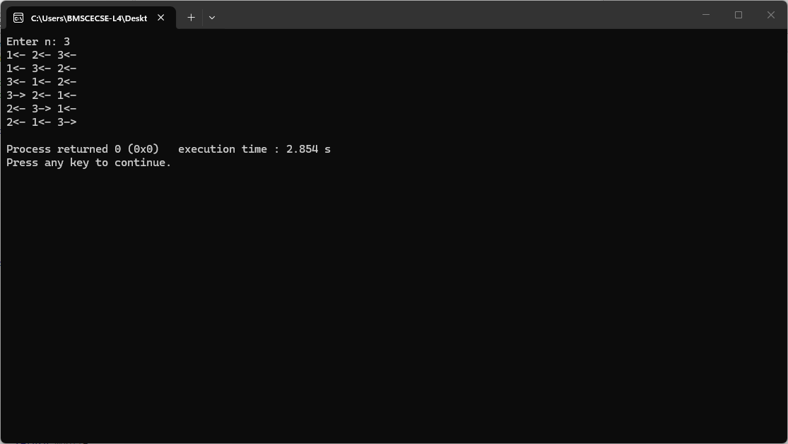

Lab program 3:
Sort a given set of N integer elements using Merge Sort technique and compute its time taken. Run the program for different values of N and record the time taken to sort.

#include <stdio.h>
#include <stdlib.h>
#include <time.h>

// Merge function
void merge(int arr[], int lb, int mid, int ub) {

int n1 = mid - lb + 1;
int n2 = ub - mid;

int L[n1], R[n2];

// Copy data
for (int i = 0; i < n1; i++)
L[i] = arr[lb + i];

for (int j = 0; j < n2; j++)
R[j] = arr[mid + 1 + j];

int i = 0, j = 0, k = lb;

// Merge arrays
while (i < n1 && j < n2) {

if (L[i] <= R[j])
arr[k++] = L[i++];

else
arr[k++] = R[j++];
}

// Remaining elements
while (i < n1)
arr[k++] = L[i++];

while (j < n2)
arr[k++] = R[j++];
}

// Merge Sort
void mergeSort(int arr[], int lb, int ub) {

if (lb < ub) {

int mid = (lb + ub) / 2;

mergeSort(arr, lb, mid);
mergeSort(arr, mid + 1, ub);

merge(arr, lb, mid, ub);
}
}

int main() {

int n;

printf("Enter number of elements: ");
scanf("%d", &n);

int arr[n];

printf("Enter elements:\n");

for (int i = 0; i < n; i++) {
scanf("%d", &arr[i]);
}

clock_t start = clock();

mergeSort(arr, 0, n - 1);

clock_t end = clock();

double time_taken =
(double)(end - start) / CLOCKS_PER_SEC;

printf("\nSorted array:\n");

for (int i = 0; i < n; i++) {
printf("%d ", arr[i]);
}

printf("\n");

printf("Time taken: %.6f seconds\n", time_taken);

return 0;
}

Screenshot of the output: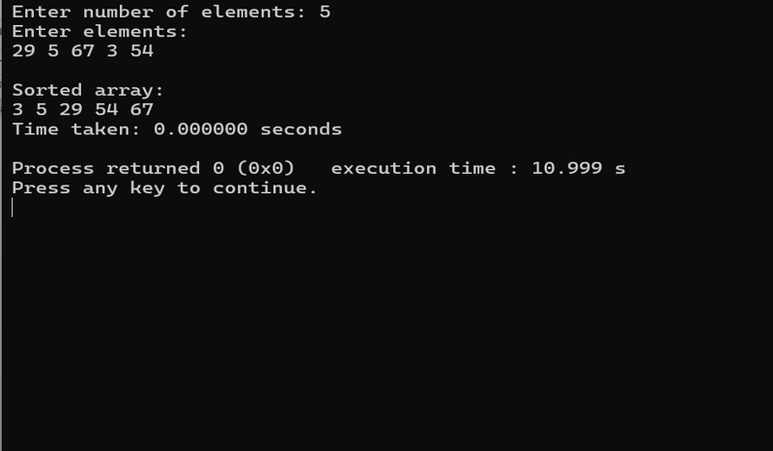
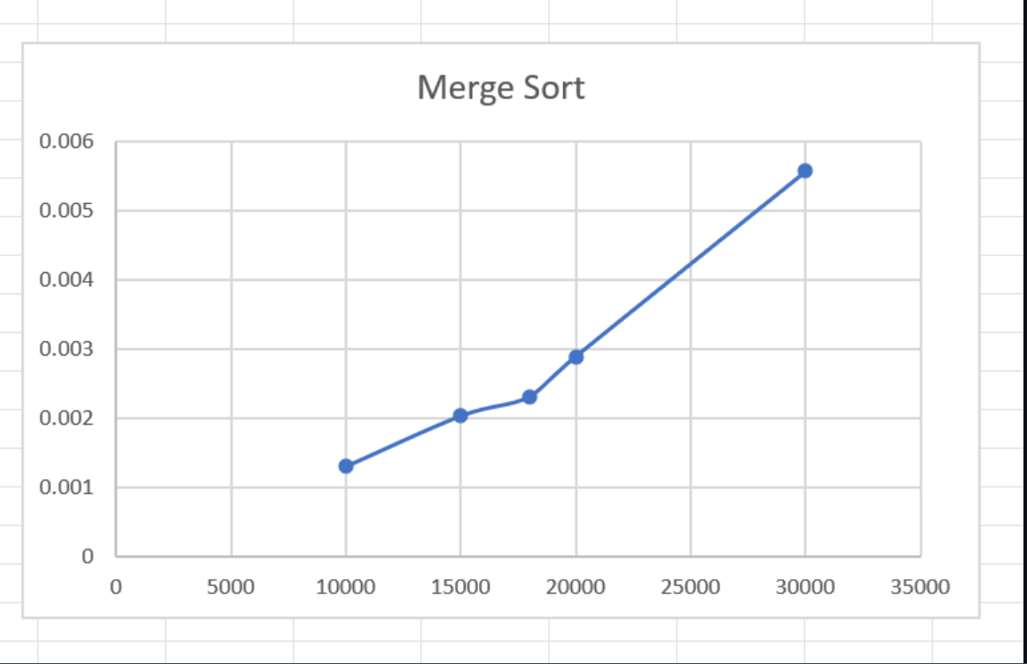

Lab program 4:
Sort a given set of N integer elements using Quick Sort technique and compute its time taken.
#include <stdio.h>
#include <stdlib.h>
#include <time.h>

// Function to swap two elements
void swap(int *a, int *b) {
int temp = *a;
*a = *b;
*b = temp;
}

// Partition function
int partition(int arr[], int low, int high) {
int pivot = arr[high]; // choosing last element as pivot
int i = (low - 1);

for (int j = low; j < high; j++) {
if (arr[j] <= pivot) {
i++;
swap(&arr[i], &arr[j]);
}
}
swap(&arr[i + 1], &arr[high]);
return (i + 1);
}

// Quick Sort function
void quickSort(int arr[], int low, int high) {
if (low < high) {
int pi = partition(arr, low, high);

quickSort(arr, low, pi - 1);
quickSort(arr, pi + 1, high);
}
}

int main() {
int N;
printf("Enter number of elements: ");
scanf("%d", &N);

int arr[N];
printf("Enter the elements:\n");
for (int i = 0; i < N; i++) {
scanf("%d", &arr[i]);
}

clock_t start, end;
start = clock();

quickSort(arr, 0, N - 1);

end = clock();

printf("Sorted array:\n");
for (int i = 0; i < N; i++) {
printf("%d ", arr[i]);
}

double time_taken = ((double)(end - start)) / CLOCKS_PER_SEC;
printf("\nTime taken: %f seconds\n", time_taken);

return 0;
}

Screenshot of the output:
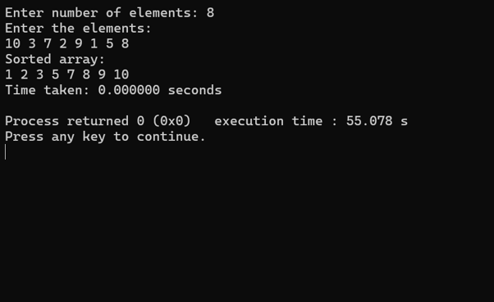
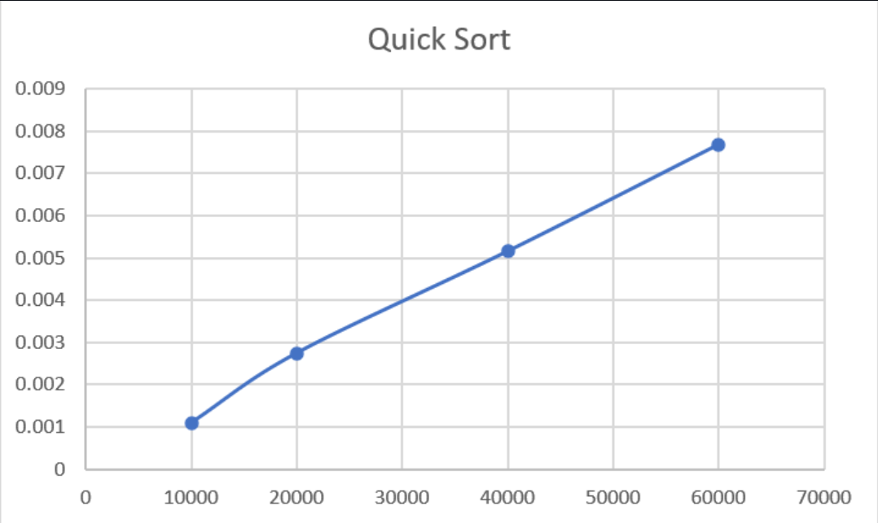

Lab program 5:
Sort a given set of N integer elements using Heap Sort technique and compute its time taken.
#include <stdio.h>
void swap(int *a, int *b) {
int temp = *a;
*a = *b;
*b = temp;
}
void siftUp(int a[], int i) {
while(i > 0) {
int parent = (i - 1) / 2;
if(a[parent] < a[i]) {
swap(&a[parent], &a[i]);
i = parent;
} else {
break;
}
}
}

// Build heap using Top-Down approach
void buildHeap(int a[], int n) {
for(int i = 1; i < n; i++) {
siftUp(a, i);
}
}
void heapify(int a[], int n, int i) {
int largest = i;
int left = 2*i + 1;
int right = 2*i + 2;

if(left < n && a[left] > a[largest])
largest = left;
if(right < n && a[right] > a[largest])
largest = right;
if(largest != i) {
swap(&a[i], &a[largest]);
heapify(a, n, largest);
}
}
void heapSort(int a[], int n) {
buildHeap(a, n);
for(int i = n-1; i > 0; i--) {
swap(&a[0], &a[i]);
heapify(a, i, 0);
}
}
void print(int a[], int n) {
for(int i = 0; i < n; i++)
printf("%d ", a[i]);
printf("\n");
}
int main() {
int n;
printf("Enter n: ");
scanf("%d", &n);

int a[n];
printf("Enter elements:\n");
for(int i = 0; i < n; i++)
scanf("%d", &a[i]);
heapSort(a, n);
printf("Sorted array:\n");
print(a, n);
return 0;
}

Screenshot of the output:
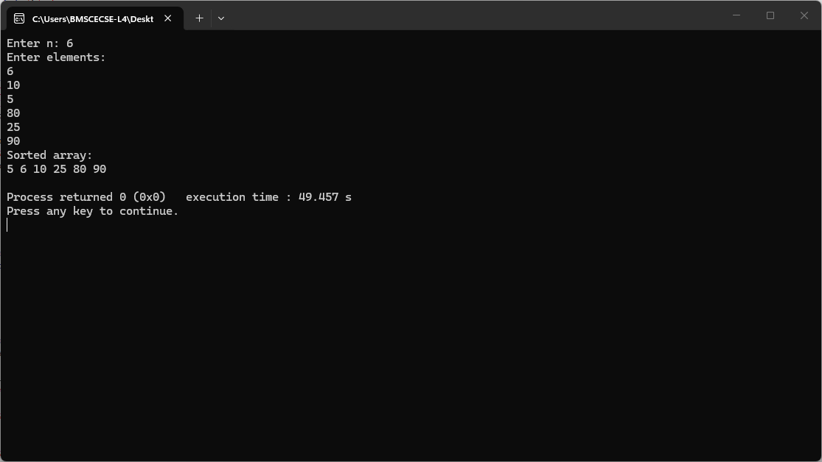

Lab program 6:
Implement 0/1 Knapsack problem using dynamic programming.

#include <stdio.h>

int knapsack(int W, int wt[], int val[], int n) {
int dp[n+1][W+1];

// Build DP table
for (int i = 0; i <= n; i++) {
for (int w = 0; w <= W; w++) {

if (i == 0 || w == 0) {
dp[i][w] = 0;
}

else if (wt[i-1] <= w) {

int include = val[i-1] + dp[i-1][w - wt[i-1]];
int exclude = dp[i-1][w];

dp[i][w] = (include > exclude) ? include : exclude;
}

else {
dp[i][w] = dp[i-1][w];
}
}
}

// Print selected items
int selected[n];

for (int i = 0; i < n; i++)
selected[i] = 0;

int i = n;
int w = W;

while (i > 0 && w > 0) {

// Item included
if (dp[i][w] != dp[i-1][w]) {
selected[i-1] = 1;
w = w - wt[i-1];
}

i--;
}

printf("\nItems included in Knapsack:\n");

for (int i = 0; i < n; i++) {
printf("%d ", selected[i]);
}

printf("\n");

return dp[n][W];
}

int main() {

int n, W;

printf("Enter number of items: ");
scanf("%d", &n);

int val[n], wt[n];

printf("Enter profit of items:\n");
for (int i = 0; i < n; i++) {
scanf("%d", &val[i]);
}

printf("Enter weights of items:\n");
for (int i = 0; i < n; i++) {
scanf("%d", &wt[i]);
}

printf("Enter knapsack capacity: ");
scanf("%d", &W);

int result = knapsack(W, wt, val, n);

printf("\nMaximum value in Knapsack = %d\n", result);

return 0;
}
Screenshot of the output:
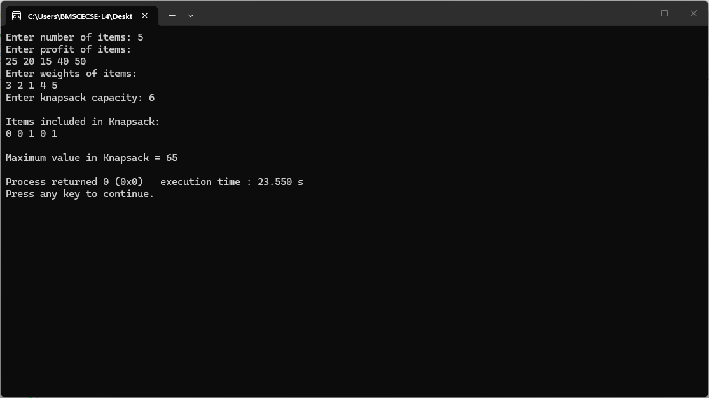

Lab program 7:
Implement All Pair Shortest paths problem using Floyd’s algorithm.
#include <stdio.h>
#define INF 99999
#define MAX 100
void printSolution(int dist[MAX][MAX], int V) {
printf("\nShortest distance matrix:\n");
for (int i = 0; i < V; i++) {
for (int j = 0; j < V; j++) {
if (dist[i][j] == INF)
printf("%7s", "INF");
else
printf("%7d", dist[i][j]);
}
printf("\n");
}
}
void floydWarshall(int graph[MAX][MAX], int V) {
int dist[MAX][MAX];
for (int i = 0; i < V; i++)
for (int j = 0; j < V; j++)
dist[i][j] = graph[i][j];

// Floyd-Warshall
for (int k = 0; k < V; k++) {
for (int i = 0; i < V; i++) {
for (int j = 0; j < V; j++) {
if (dist[i][k] < INF && dist[k][j] < INF &&
dist[i][k] + dist[k][j] < dist[i][j]) {
dist[i][j] = dist[i][k] + dist[k][j];
}
}
} }
for (int i = 0; i < V; i++) {
if (dist[i][i] < 0) {
printf("\nNegative cycle detected!\n");
return;
}
}
printSolution(dist, V);
}
int main() {
int V;
int graph[MAX][MAX];
printf("Enter number of vertices: ");
scanf("%d", &V);
printf("\nEnter adjacency matrix (-1 for no edge):\n");
for (int i = 0; i < V; i++) {
for (int j = 0; j < V; j++) {
scanf("%d", &graph[i][j]);
if (graph[i][j] == -1)
graph[i][j] = INF;
}
}
for (int i = 0; i < V; i++)
graph[i][i] = 0;
floydWarshall(graph, V);
return 0;}

Screenshot of the output:
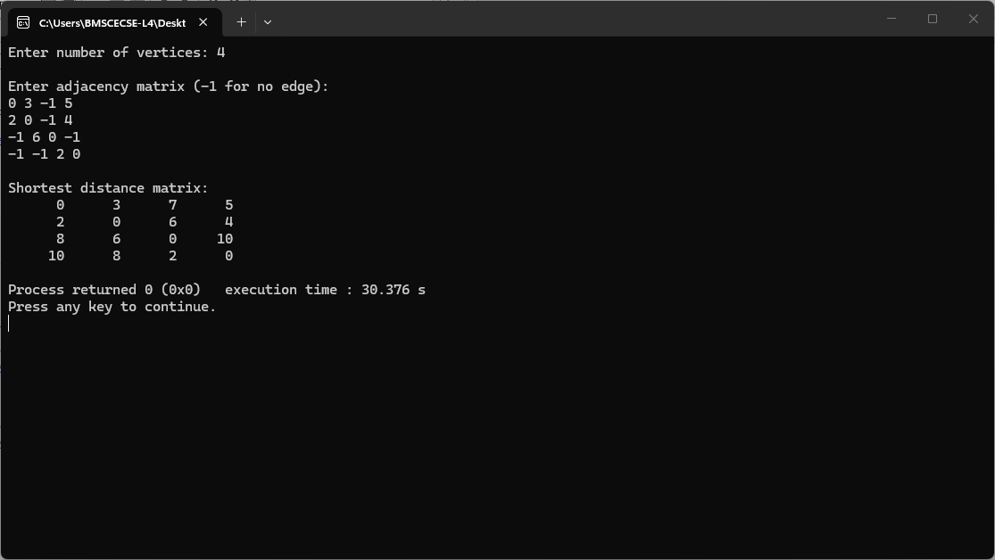

Lab program 8a:
Find Minimum Cost Spanning Tree of a given undirected graph using Prim’s algorithm.

#include <stdio.h>
#include <limits.h>
int minKey(int key[], int mstSet[], int V) {
int min = INT_MAX, min_index = -1;
for (int v = 0; v < V; v++)
if (mstSet[v] == 0 && key[v] < min)
min = key[v], min_index = v;
return min_index;
}
void primMST(int graph[50][50], int V) {
int parent[V], key[V], mstSet[V];
int totalCost = 0;

for (int i = 0; i < V; i++) {
key[i] = INT_MAX;
mstSet[i] = 0;
}
key[0] = 0;
parent[0] = -1;
for (int count = 0; count < V - 1; count++) {
int u = minKey(key, mstSet, V);
mstSet[u] = 1;

for (int v = 0; v < V; v++)
if (graph[u][v] && mstSet[v] == 0 && graph[u][v] < key[v]) {
parent[v] = u;
key[v] = graph[u][v];
}
}

printf("\nEdges in MST:\n");
for (int i = 1; i < V; i++) {
printf("%d - %d : %d\n", parent[i], i, graph[i][parent[i]]);
totalCost += graph[i][parent[i]];
}
printf("Total cost = %d\n", totalCost);
}
int main() {
int V;
int graph[50][50];
printf("Enter number of vertices: ");
scanf("%d", &V);
printf("Enter adjacency matrix (enter 0 if no edge, otherwise enter cost):\n");
for (int i = 0; i < V; i++)
for (int j = 0; j < V; j++)
scanf("%d", &graph[i][j]);

primMST(graph, V);

return 0;
}

Screenshot of the output:
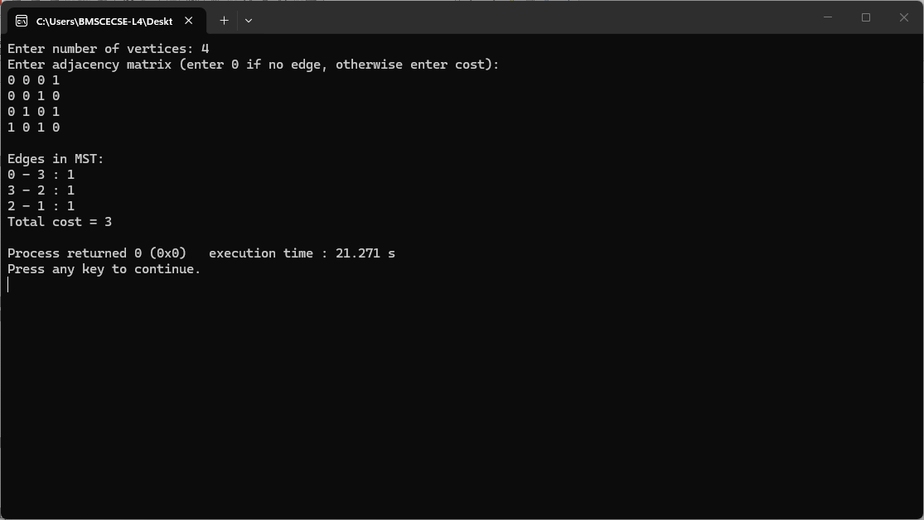

Lab program 8b:
Find Minimum Cost Spanning Tree of a given undirected graph using Kruskal’s algorithm.

#include <stdio.h>
#include <stdlib.h>
struct Edge {
int src,dest,weight;
};
struct Subset {
int parent;
};
int find(struct Subset subsets[],int i){
while(subsets[i].parent!=i)
i=subsets[i].parent;
return i;
}
void Union(struct Subset subsets[],int x,int y){
int xroot=find(subsets,x);
int yroot=find(subsets,y);
subsets[xroot].parent=yroot;
}
int compare(const void *a,const void *b){
return ((struct Edge*)a)->weight-((struct Edge*)b)->weight;
}
void KruskalMST(struct Edge edges[],int V,int E){
struct Edge result[V];
struct Subset subsets[V];
qsort(edges,E,sizeof(struct Edge),compare);
for(int i=0;i<V;i++)
subsets[i].parent=i;
int e=0;
int i=0;
while(e<V-1&&i<E){
struct Edge next=edges[i++];
int x=find(subsets,next.src);
int y=find(subsets,next.dest);
if(x!=y){
result[e++]=next;
Union(subsets,x,y);
}
}
printf("\nEdges in MST:\n");
int total=0;
for(i=0;i<e;i++){
printf("%d -- %d == %d\n",result[i].src,result[i].dest,result[i].weight);
total+=result[i].weight;
}
printf("Total Cost = %d\n",total);
}
int main(){
int V;
printf("Enter number of vertices: ");
scanf("%d",&V);
int E=V*(V-1)/2;
struct Edge edges[E];
printf("Enter edges (src dest weight):\n");
for(int i=0;i<E;i++){
scanf("%d %d %d",&edges[i].src,&edges[i].dest,&edges[i].weight);
}
KruskalMST(edges,V,E);
return 0;
}

Screenshot of the output: 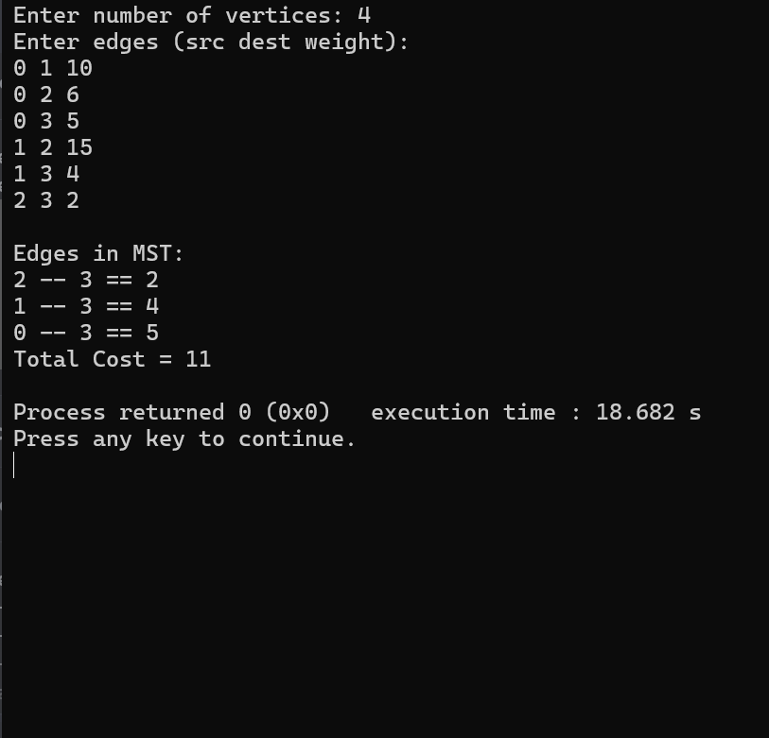

Lab program 9:
Implement Fractional Knapsack using Greedy technique

#include <stdio.h>
struct Item{int weight;int value;};
int main(){
int n,capacity;
printf("Enter number of items: ");
scanf("%d",&n);
struct Item items[n];
for(int i=0;i<n;i++){
printf("Enter weight and value of item %d: ",i+1);
scanf("%d %d",&items[i].weight,&items[i].value);
}
printf("Enter knapsack capacity: ");
scanf("%d",&capacity);
double ratio[n];
for(int i=0;i<n;i++)ratio[i]=(double)items[i].value/items[i].weight;
for(int i=0;i<n-1;i++){
for(int j=i+1;j<n;j++){
if(ratio[i]<ratio[j]){
double tempR=ratio[i];ratio[i]=ratio[j];ratio[j]=tempR;
struct Item temp=items[i];items[i]=items[j];items[j]=temp;
}
}
}
double maxValue=0.0;int remaining=capacity;
for(int i=0;i<n;i++){
if(items[i].weight<=remaining){
remaining-=items[i].weight;
maxValue+=items[i].value;
}else{
maxValue+=ratio[i]*remaining;
break;
}
}
printf("Maximum value in Knapsack = %.2f\n",maxValue);
return 0;
}

Screenshot of the output:
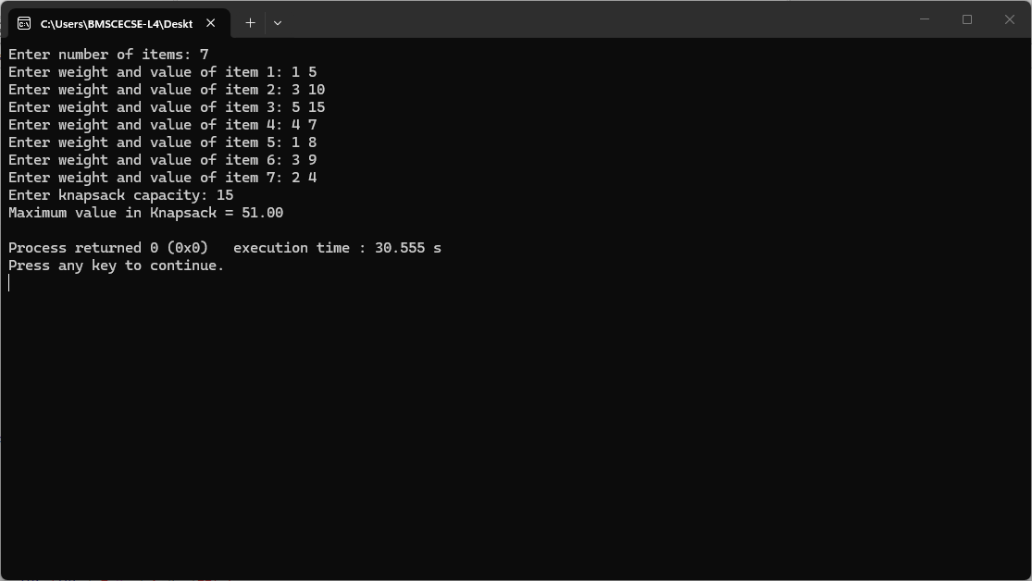

Lab program 10:
From a given vertex in a weighted connected graph, find shortest paths to other vertices using Dijkstra’s algorithm.

#include <stdio.h>
#include <limits.h>
#define V 10 // maximum number of vertices
int minDistance(int dist[], int sptSet[], int vertices) {
int min = INT_MAX, min_index;
for (int v = 0; v < vertices; v++) {
if (sptSet[v] == 0 && dist[v] <= min) {
min = dist[v];
min_index = v;
}
}
return min_index;
}
void printSolution(int dist[], int vertices, int src) {
printf("Vertex \t Distance from Source %d\n", src);
for (int i = 0; i < vertices; i++) {
printf("%d \t %d\n", i, dist[i]);
}
}

void dijkstra(int graph[V][V], int src, int vertices) {
int dist[vertices]; // shortest distance from src
int sptSet[vertices]; // whether vertex is included in shortest path tree

for (int i = 0; i < vertices; i++) {
dist[i] = INT_MAX;
sptSet[i] = 0;
}
dist[src] = 0;
for (int count = 0; count < vertices - 1; count++) {
int u = minDistance(dist, sptSet, vertices);
sptSet[u] = 1;
for (int v = 0; v < vertices; v++) {
if (!sptSet[v] && graph[u][v] && dist[u] != INT_MAX
&& dist[u] + graph[u][v] < dist[v]) {
dist[v] = dist[u] + graph[u][v];
}
}
}
printSolution(dist, vertices, src);
}
int main() {
int vertices;
printf("Enter number of vertices: ");
scanf("%d", &vertices)
int graph[V][V];
printf("Enter adjacency matrix (0 if no edge):\n");
for (int i = 0; i < vertices; i++) {
for (int j = 0; j < vertices; j++) {
scanf("%d", &graph[i][j]);
}
}

int src;
printf("Enter source vertex: ");
scanf("%d", &src);

dijkstra(graph, src, vertices);

return 0;
}

Screenshot of the output:
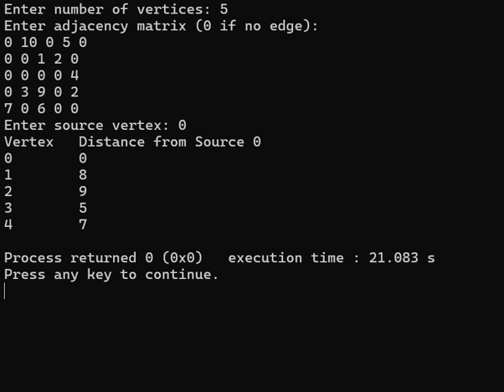

Lab program 11:
Implement “N-Queens Problem” using Backtracking.
#include <stdio.h>
#include <stdbool.h>
#define MAX 20
int N;
int board[MAX][MAX];
bool isSafe(int row,int col){
for(int i=0;i<row;i++){
if(board[i][col])return false;
if(col-(row-i)>=0&&board[i][col-(row-i)])return false;
if(col+(row-i)<N&&board[i][col+(row-i)])return false;
}
return true;
}
void printBoard(){
for(int i=0;i<N;i++){
for(int j=0;j<N;j++)printf("%c ",board[i][j]?'Q':'.');
printf("\n");
}
printf("\n");
}
void solve(int row){
if(row==N){
printBoard();
return;
}
for(int col=0;col<N;col++){
if(isSafe(row,col)){
board[row][col]=1;
solve(row+1);
board[row][col]=0;
}
}
}
int main(){
printf("Enter the size of the board (N): ");
scanf("%d",&N);
if(N>MAX||N<1){
printf("Invalid board size. Please enter between 1 and %d.\n",MAX);
return 1;
}
solve(0);
return 0;
}

Screenshot of the output:
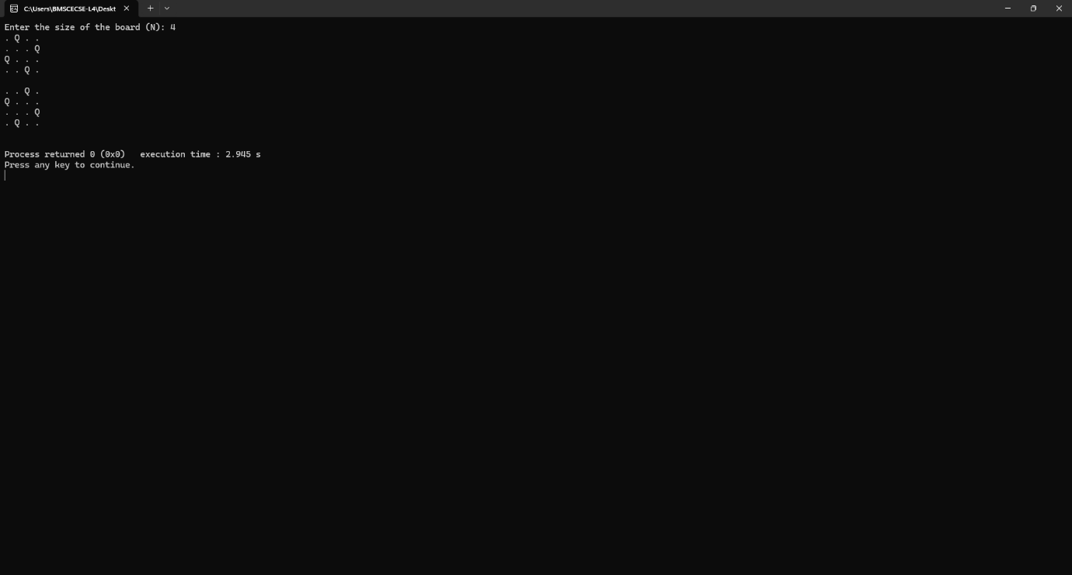

LEETCODE

Leetcode 3658: GCD of odd and even sums

int gcdOfOddEvenSums(int n) {

int oddSum = n * n;
int evenSum = n * (n + 1);

// find gcd using Euclidean algorithm
while (evenSum != 0) {
int temp = evenSum;
evenSum = oddSum % evenSum;
oddSum = temp;
}

return oddSum;
}
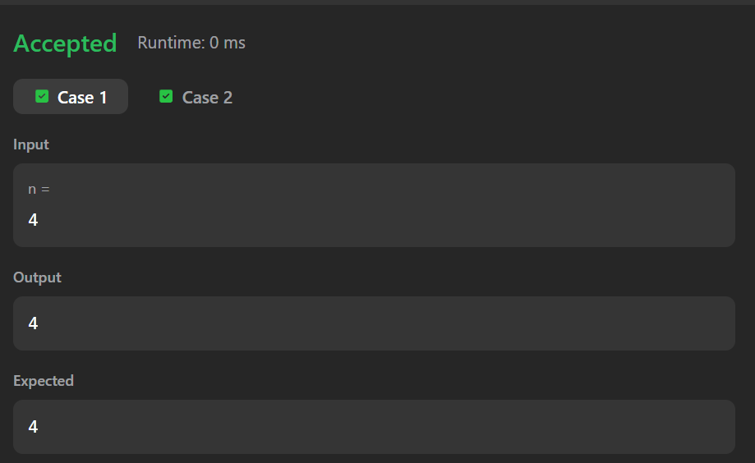

Leetcode 2447: No of subarrays with GCD equal to k

int gcd(int a, int b) {
while (b != 0) {
int temp = b;
b = a % b;
a = temp;
}
return a;
}

int subarrayGCD(int* nums, int numsSize, int k) {

int count = 0;

for (int i = 0; i < numsSize; i++) {

int currentGCD = 0;

for (int j = i; j < numsSize; j++) {

currentGCD = gcd(currentGCD, nums[j]);

if (currentGCD == k) {
count++;
}
else if (currentGCD < k) {
break;
}
}
}

return count;
}

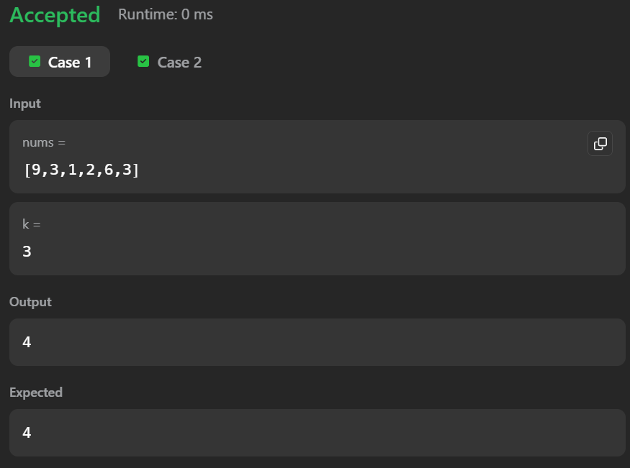

Leetcode 1819: No of different subsequences GCDs
int gcd(int a, int b) {
while (b != 0) {
int temp = b;
b = a % b;
a = temp;
}
return a;
}

int countDifferentSubsequenceGCDs(int* nums, int numsSize) {

int maxNum = 0;

for (int i = 0; i < numsSize; i++) {
if (nums[i] > maxNum) {
maxNum = nums[i];
}
}

int* exists = (int*)calloc(maxNum + 1, sizeof(int));

for (int i = 0; i < numsSize; i++) {
exists[nums[i]] = 1;
}

int answer = 0;

for (int x = 1; x <= maxNum; x++) {

int currentGCD = 0;
for (int multiple = x; multiple <= maxNum; multiple += x) {

if (exists[multiple]) {
currentGCD = gcd(currentGCD, multiple);

if (currentGCD == x) {
answer++;
break;
}
}
}
}

free(exists);
return answer;
}
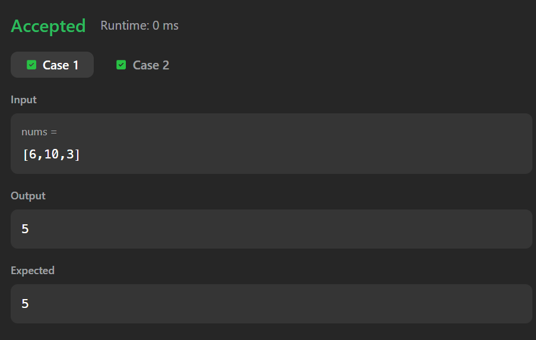

Leetcode 3867: Sum of GCD of formed pairs

int gcd(int a, int b) {
while (b != 0) {
int temp = b;
b = a % b;
a = temp;
}
return a;
}
int cmp(const void* a, const void* b) {
return (*(int*)a - *(int*)b);
}
long long gcdSum(int* nums, int numsSize) {

int* prefixGcd = (int*)malloc(numsSize * sizeof(int));

int mx = 0;

// build prefixGcd array
for (int i = 0; i < numsSize; i++) {

if (nums[i] > mx) {
mx = nums[i];
}
prefixGcd[i] = gcd(nums[i], mx);
}

qsort(prefixGcd, numsSize, sizeof(int), cmp);
long long sum = 0;

int left = 0;
int right = numsSize - 1;
while (left < right) {

sum += gcd(prefixGcd[left], prefixGcd[right]);

left++;
right--;
}

free(prefixGcd);
return sum;
}
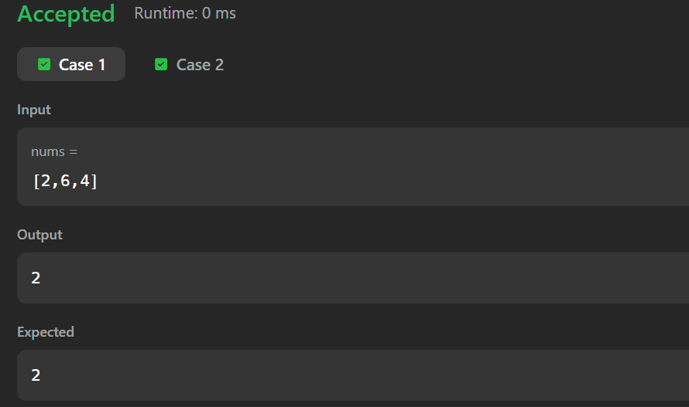

Leetcode 207: Course Schedule

bool canFinish(int numCourses, int** prerequisites, int prerequisitesSize, int* prerequisitesColSize) {

int* indegree = (int*)calloc(numCourses, sizeof(int));

int** graph = (int**)malloc(numCourses * sizeof(int*));
int* graphSize = (int*)calloc(numCourses, sizeof(int));

for (int i = 0; i < numCourses; i++) {
graph[i] = (int*)malloc(prerequisitesSize * sizeof(int));
}

// build graph
for (int i = 0; i < prerequisitesSize; i++) {
int a = prerequisites[i][0];
int b = prerequisites[i][1];

graph[b][graphSize[b]++] = a;
indegree[a]++;
}

int* queue = (int*)malloc(numCourses * sizeof(int));
int front = 0, rear = 0;

// push nodes with indegree 0
for (int i = 0; i < numCourses; i++) {
if (indegree[i] == 0) {
queue[rear++] = i;
}
}

int count = 0;

while (front < rear) {

int node = queue[front++];
count++;

for (int i = 0; i < graphSize[node]; i++) {

int next = graph[node][i];
indegree[next]--;

if (indegree[next] == 0) {
queue[rear++] = next;
}
}
}

for (int i = 0; i < numCourses; i++) {
free(graph[i]);
}

free(graph);
free(graphSize);
free(indegree);
free(queue);
return count == numCourses;
}

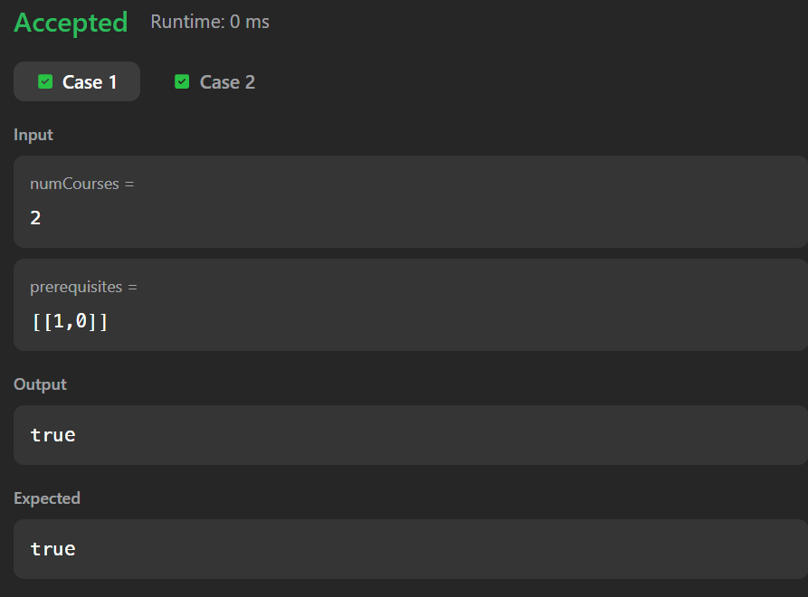

Leetcode 1334: Find the city with the smallest no of neighbors at a threshold distance

#define INF 100000000

int findTheCity(int n, int** edges, int edgesSize, int* edgesColSize, int distanceThreshold) {

int dist[101][101];

for (int i = 0; i < n; i++) {
for (int j = 0; j < n; j++) {

if (i == j)
dist[i][j] = 0;
else
dist[i][j] = INF;
}
}

for (int i = 0; i < edgesSize; i++) {

int u = edges[i][0];
int v = edges[i][1];
int w = edges[i][2];

dist[u][v] = w;
dist[v][u] = w;
}

for (int k = 0; k < n; k++) {
for (int i = 0; i < n; i++) {
for (int j = 0; j < n; j++) {

if (dist[i][k] + dist[k][j] < dist[i][j]) {
dist[i][j] = dist[i][k] + dist[k][j];
}
}
}
}

int answer = -1;
int minReachable = INF;

for (int i = 0; i < n; i++) {

int count = 0;

for (int j = 0; j < n; j++) {

if (i != j && dist[i][j] <= distanceThreshold) {
count++;
}
}
if (count <= minReachable) {
minReachable = count;
answer = i;
}
}

return answer;
}

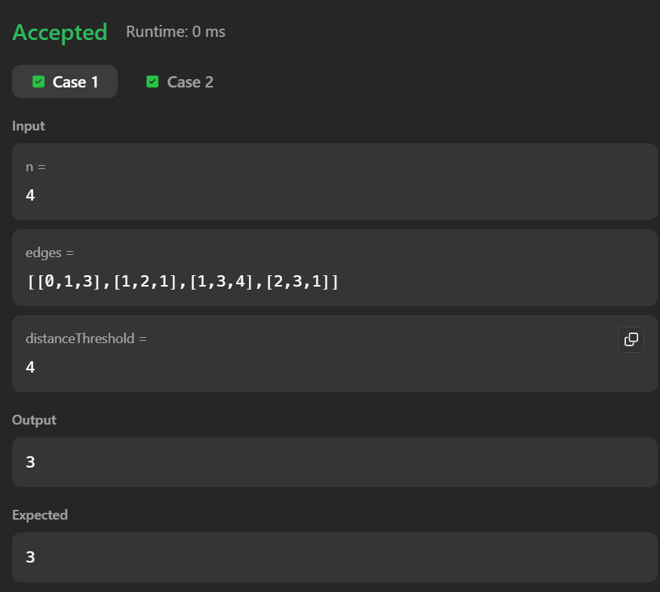

Leetcode 912: Sort an array

void merge(int* nums, int left, int mid, int right) {

int n1 = mid - left + 1;
int n2 = right - mid;

int L[n1], R[n2];

for (int i = 0; i < n1; i++)
L[i] = nums[left + i];

for (int i = 0; i < n2; i++)
R[i] = nums[mid + 1 + i];

int i = 0, j = 0, k = left;

while (i < n1 && j < n2) {

if (L[i] <= R[j]) {
nums[k++] = L[i++];
} else {
nums[k++] = R[j++];
}
}

while (i < n1) {
nums[k++] = L[i++];
}

while (j < n2) {
nums[k++] = R[j++];
}
}

void mergeSort(int* nums, int left, int right) {

if (left >= right)
return;

int mid = left + (right - left) / 2;

mergeSort(nums, left, mid);
mergeSort(nums, mid + 1, right);

merge(nums, left, mid, right);
}

int* sortArray(int* nums, int numsSize, int* returnSize) {

mergeSort(nums, 0, numsSize - 1);

*returnSize = numsSize;

return nums;
}

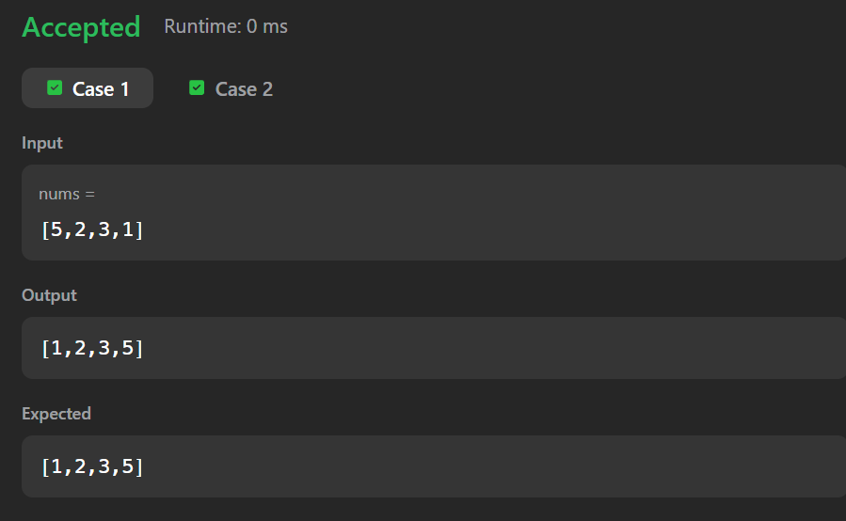

Leetcode 494: Target Sum

int findTargetSumWays(int* nums, int numsSize, int target) {

int totalSum = 0;

for (int i = 0; i < numsSize; i++) {
totalSum += nums[i];
}

// impossible case
if ((target + totalSum) % 2 != 0 || abs(target) > totalSum) {
return 0;
}

int subsetSum = (target + totalSum) / 2;

int dp[subsetSum + 1];

for (int i = 0; i <= subsetSum; i++) {
dp[i] = 0;
}

dp[0] = 1;

for (int i = 0; i < numsSize; i++) {

for (int j = subsetSum; j >= nums[i]; j--) {
dp[j] += dp[j - nums[i]];
}
}

return dp[subsetSum];
}

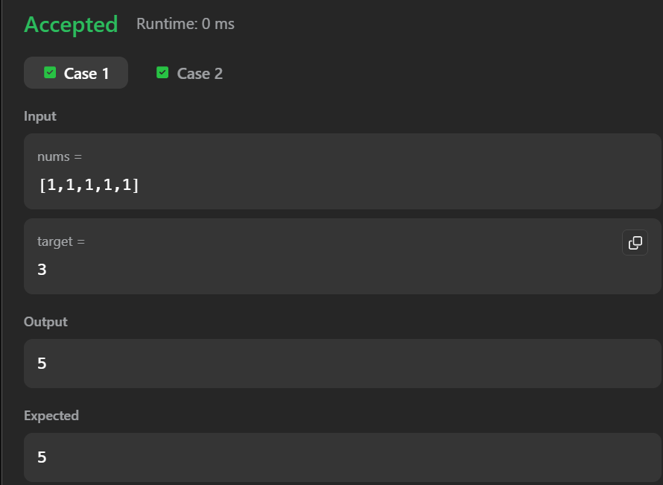

Leetcode 316: Remove duplicate letters

char* removeDuplicateLetters(char* s) {

int freq[26] = {0};
int visited[26] = {0};

int n = strlen(s);

for (int i = 0; i < n; i++) {
freq[s[i] - 'a']++;
}

char* stack = (char*)malloc((n + 1) * sizeof(char));
int top = -1;

for (int i = 0; i < n; i++) {

char ch = s[i];

freq[ch - 'a']--;

if (visited[ch - 'a']) {
continue;
}

while (top >= 0 &&
stack[top] > ch &&
freq[stack[top] - 'a'] > 0) {

visited[stack[top] - 'a'] = 0;
top--;
}

stack[++top] = ch;
visited[ch - 'a'] = 1;
}

stack[top + 1] = '\0';

return stack;
}

